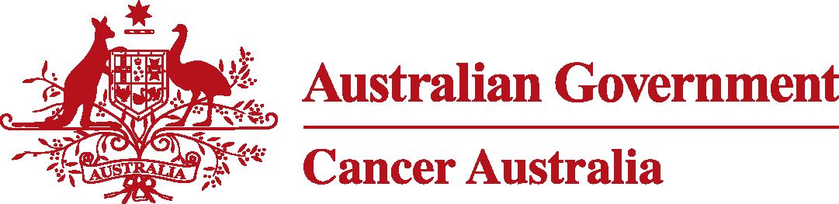

**Cancer Australia Breast Cancer Statement – Context Video**

**Speaking: Megan Hutchins**

I feel I had all the information and support I needed after my breast cancer diagnosis, and I would like to think all women can receive the same high level of care and treatment.

**Speaking: Professor Helen Zorbas**

While survival for women with breast cancer in Australia is among the highest in the world, there is evidence that not all patients are receiving the most appropriate care. And this can have an impact on their experiences and outcomes.

Patients are at the centre of our efforts to maximise clinical benefit, minimise harm and deliver care that’s right for them.

We undertook a systematic, evidence-based approach to the development of the Statement

….and brought all the key clinical and cancer organisations together with women affected by breast cancer to identify and agree the priority areas of practice.

**Speaking: Megan Hutchins**

For patients, it’s important that the *Statement* highlights areas of breast cancer care that need more attention….

Because some patients are not having the same experience or getting the information they need about the options that are right for them.

**Speaking: Professor Helen Zorbas**

The value of the *Statement* will be realised in informing and influencing wise decision making between patients and their health care

professionals.